

Name: Shehryar

Roll No: BSF2000745

Class: BS IT Evening

Semester: fourth

Teacher Name: Ms. Faiza Tariq

Course Code: COMP2115

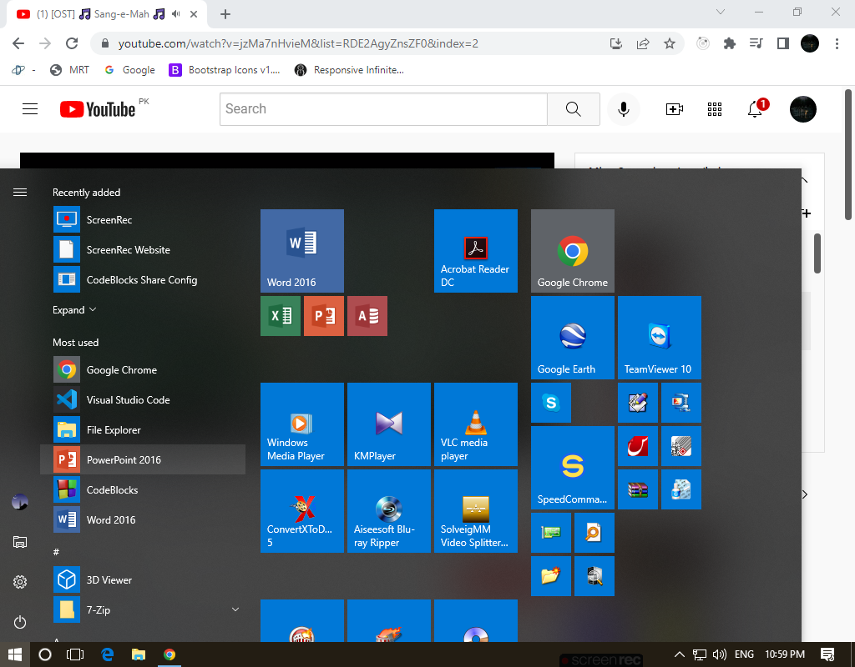

Step 1:

First press window button



Step 2:

Secondly press Setting button.

Step 3:

Third press account button.

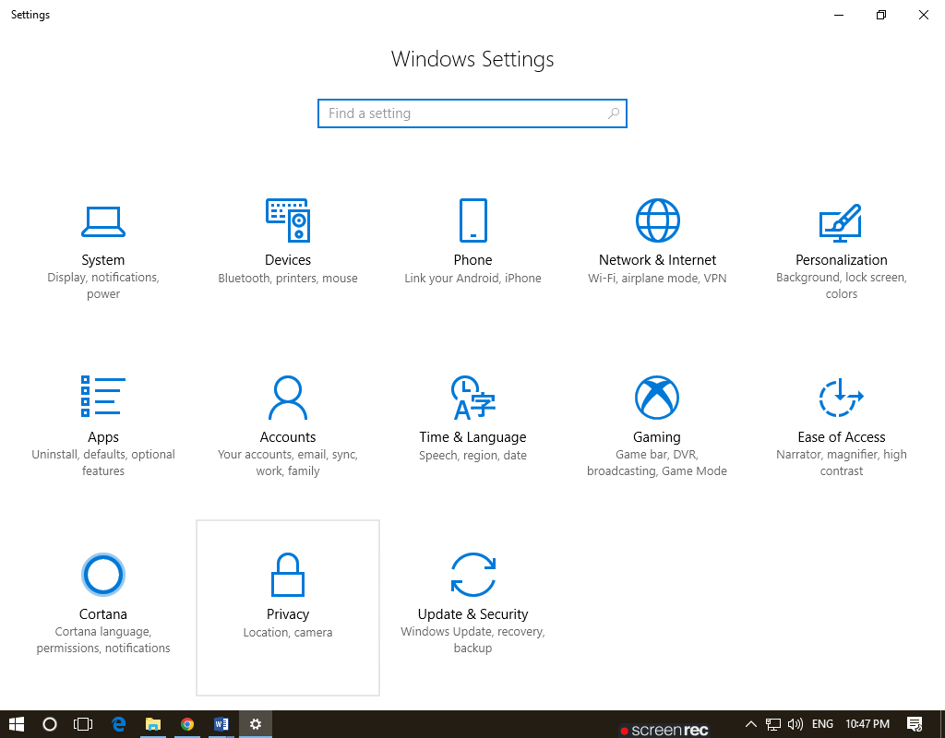

Step 4:

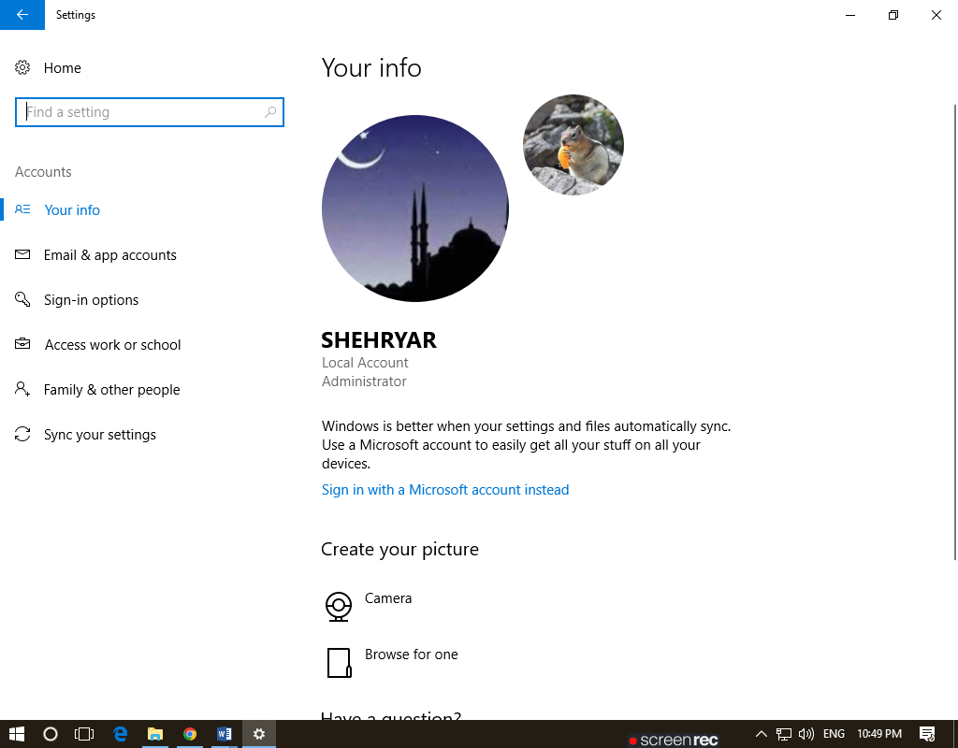 Fourthly press this button family & other people

Step 5:

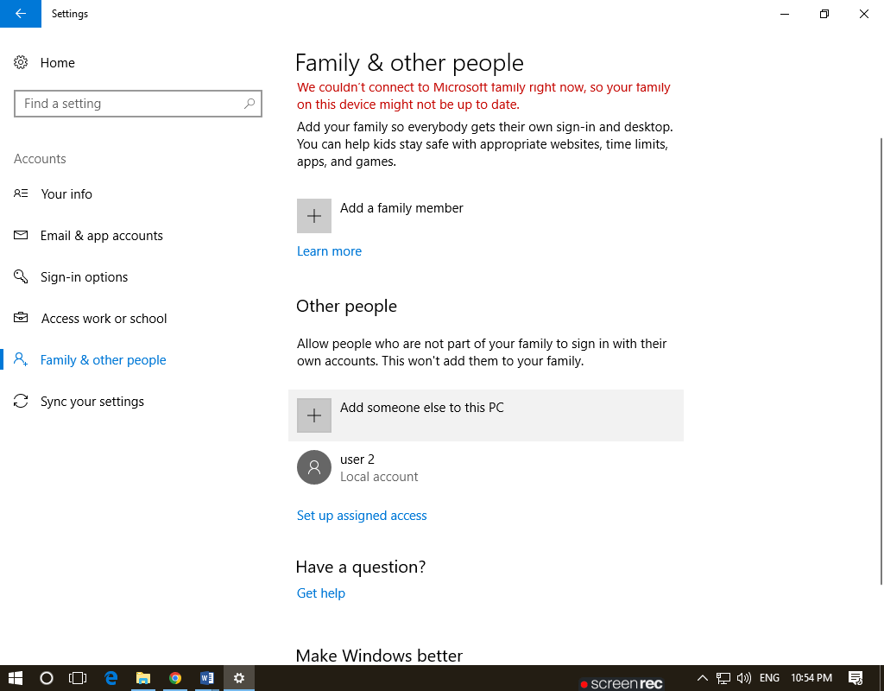 Fifth press the button

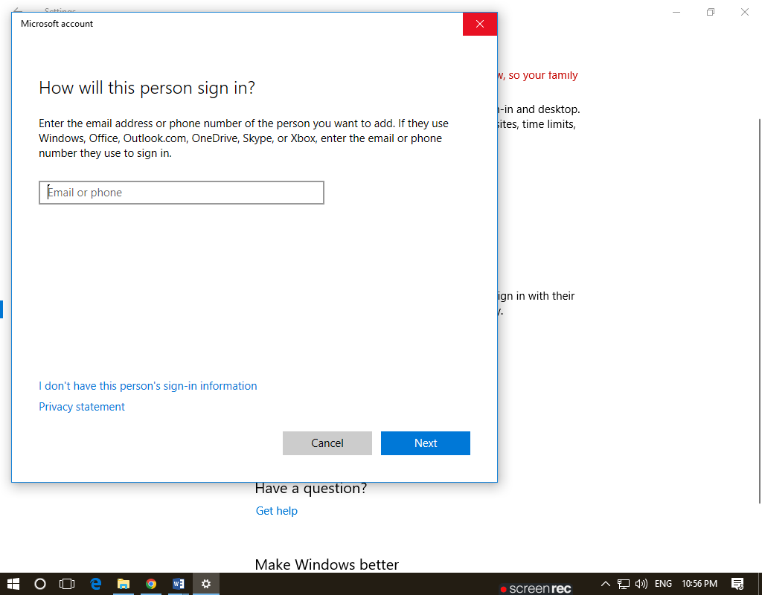Step 6:

Sixth press the button

I do not have this person sign in

Information.

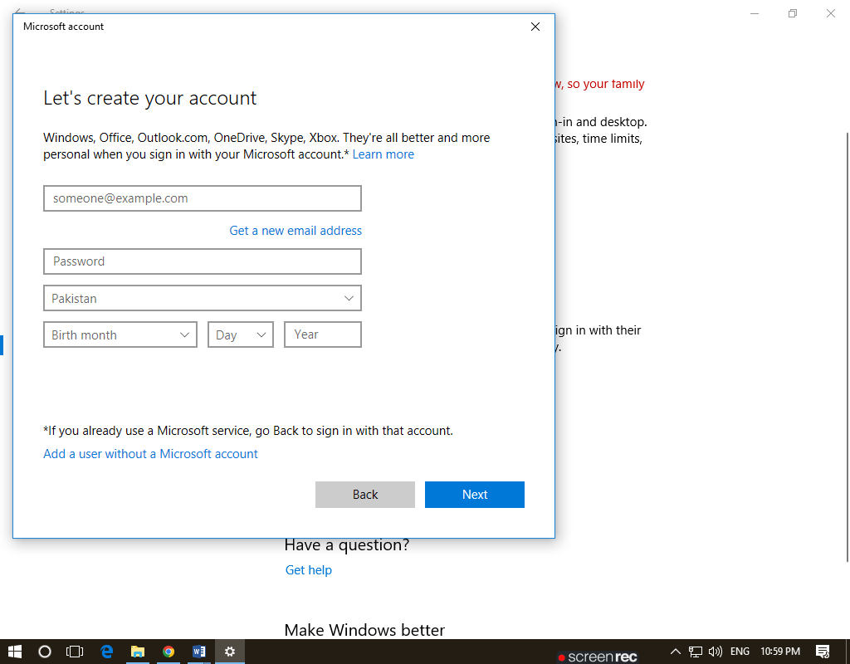Step 7:

Seventh, press this button

Add a user without a Microsoft

account

**Step 8:**

Eight, press this next button

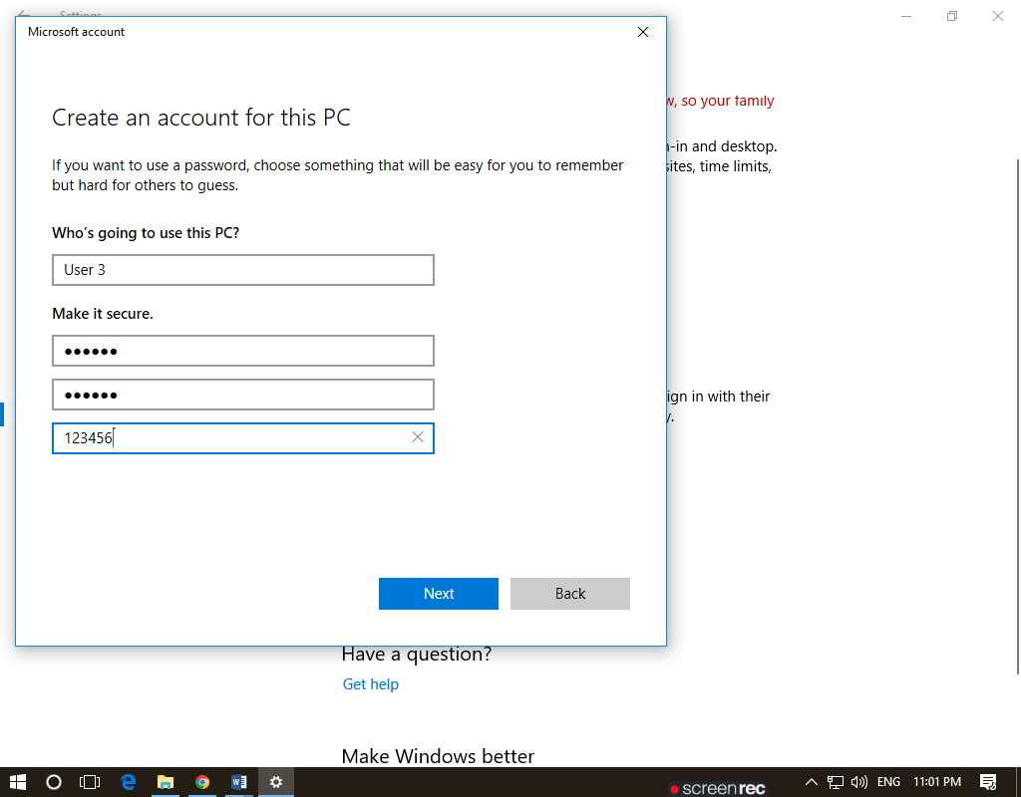

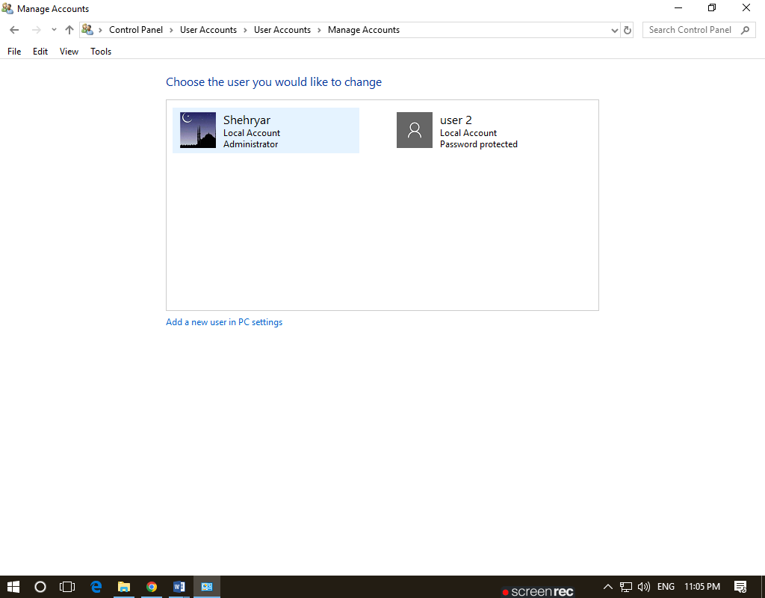Finally Your local user ready

**Different Restriction apply**

If user want to install any software then local user cannot install any software

